**#TakingThePip Social Posts and ALT Text**

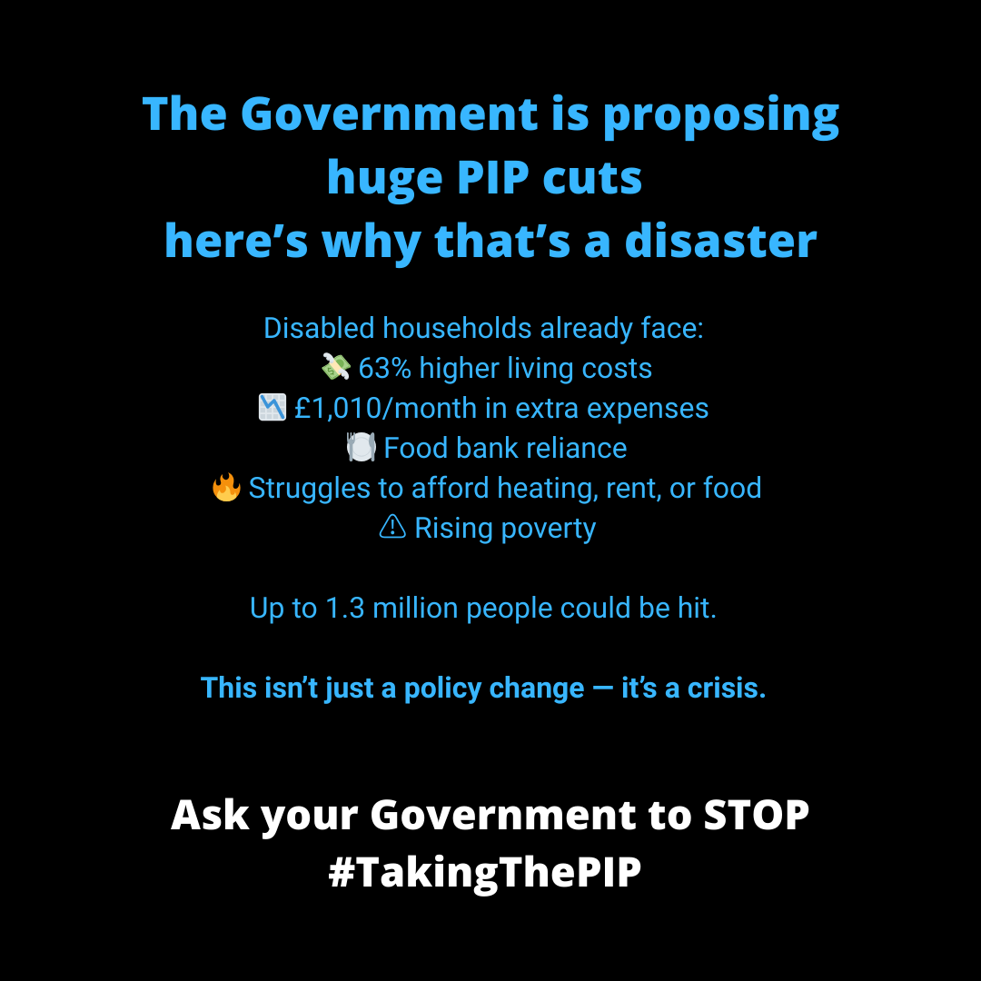

**ALT text for: #TakingThePIP why it's a disaster**

Graphic with a black background and blue and white text, titled: **"The Government is proposing huge PIP cuts — here’s why that’s a disaster"** Below the heading, a list explains the impact on disabled households: 63% higher living costs, £1,010/month in extra expenses, Food bank reliance, Struggles to afford heating, rent, or food and Rising poverty.  
Text underneath reads: **"Up to 1.3 million people could be hit."**In bold blue text: **"This isn’t just a policy change — it’s a crisis."** At the bottom in bold white text:**"Ask your Government to STOP #TakingThePIP"**

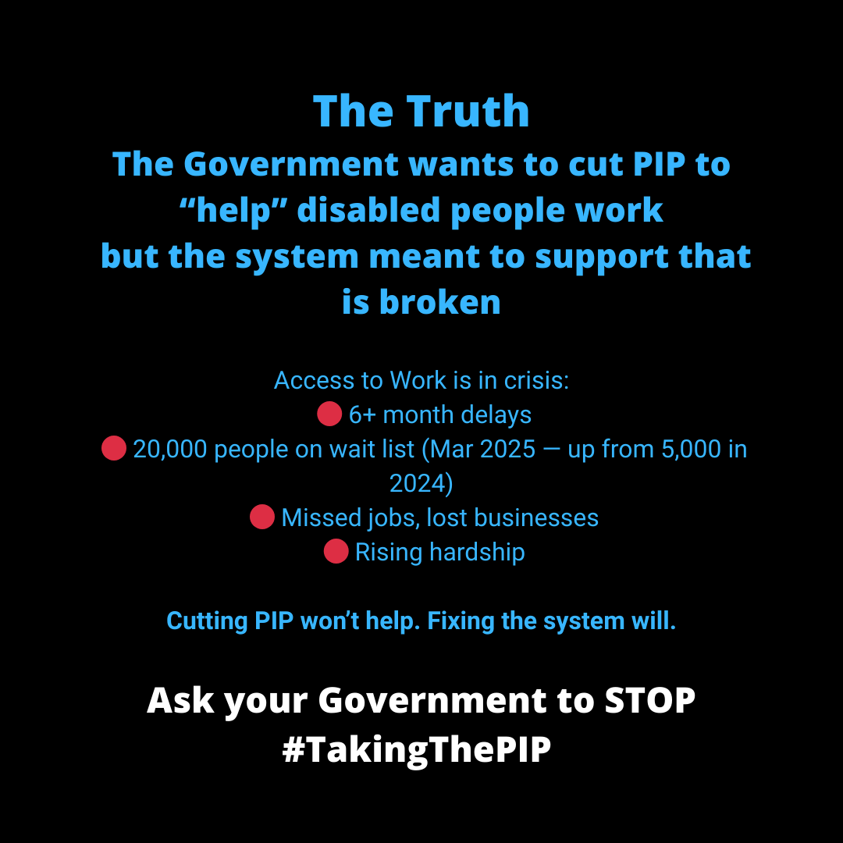

**ALT Text for: #TakingThePIP Access to work crisis**

Black background with bold blue and white text. Headline reads:**"The Truth:** The Government wants to cut PIP to 'help' disabled people work but the system meant to support that is broken" The graphic continues:**"Access to Work is in crisis:** 6+ month delays, 20,000 people on wait list (March 2025 — up from 5,000 in 2024), Missed jobs, lost businesses Rising hardship" In bold blue text: **"Cutting PIP won’t help. Fixing the system will."** At the bottom, in bold white text: **"Ask your Government to STOP #TakingThePIP"**

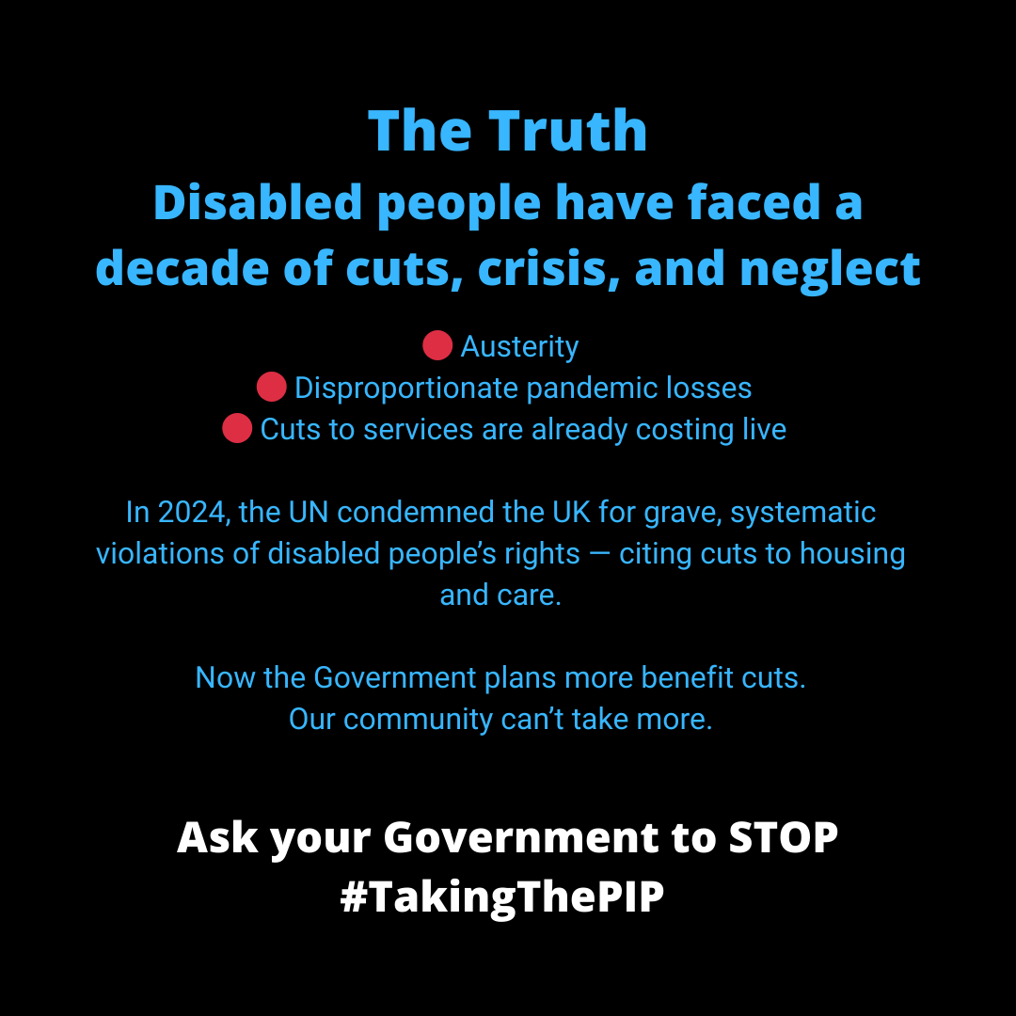

**ALT Text for: #TakingThePIP Disabled People Have Faced a Decade of Neglect**

Black background with bold blue and white text stating: "The Truth: Disabled people have faced a decade of cuts, crisis, and neglect." Three red bullet points list: "Austerity," "Disproportionate pandemic losses," and "Cuts to services are already costing lives." Below that, text notes that in 2024, the UN condemned the UK for systematic violations of disabled people's rights due to cuts to housing and care. It warns that the government is planning more benefit cuts, stating: "Our community can’t take more." At the bottom, white bold text urges: "Ask your Government to STOP #TakingThePIP."

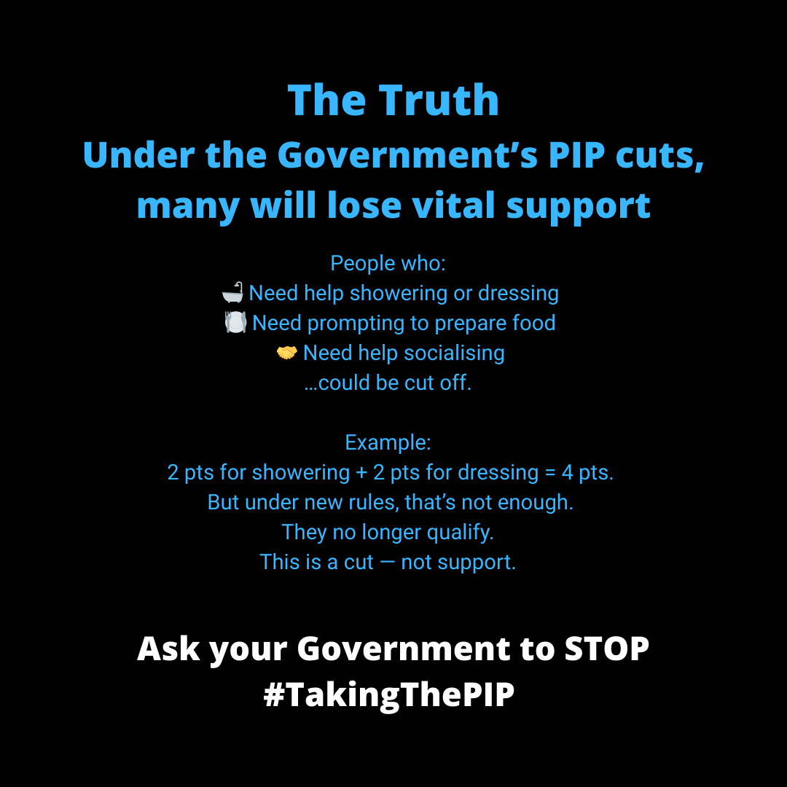

**ALT Text for: #TakingThePIP Vital Support Lose**

Black background with bold blue and white text stating: "The Truth: Under the Government’s PIP cuts, many will lose vital support." It explains that people who need help showering or dressing, prompting to prepare food, or help socialising could be cut off. An example is given: someone who gets 2 points for showering and 2 for dressing (total 4 points) would no longer qualify under new rules. It states: "This is a cut — not support." At the bottom, white bold text urges: "Ask your Government to STOP #TakingThePIP."

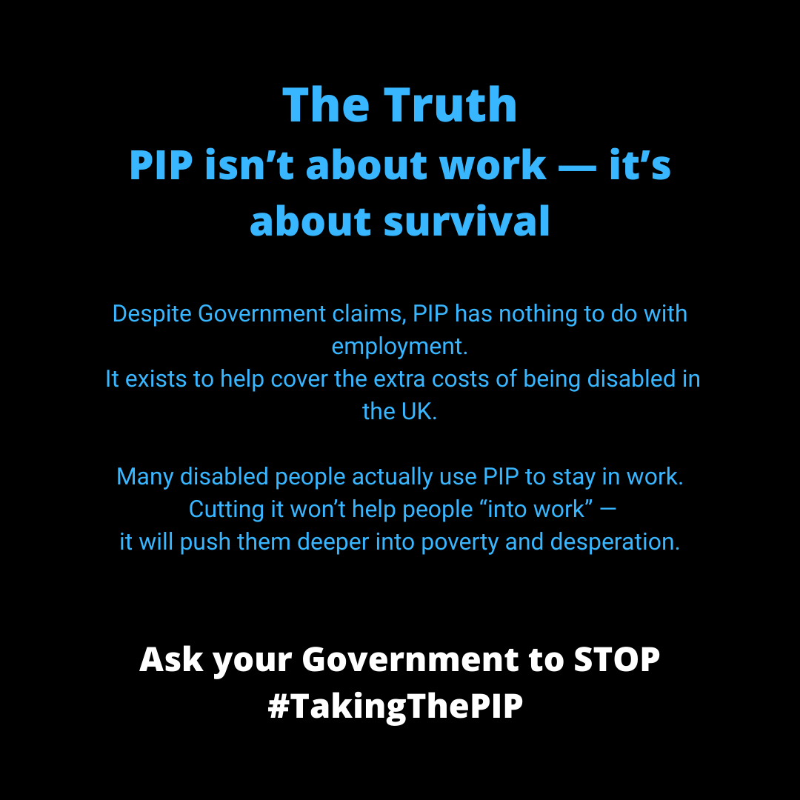

**ALT Text for: #TakingThePIP PIP isn't about work it's about survival**

Black background with bold blue and white text stating: "The Truth: PIP isn’t about work - it’s about survival.” It goes on to explain “Despite Government claims, PIP has nothing to do with employment. It exists to help cover the extra costs of being disabled in the UK. Many disabled people actually uses PIP to stay in work. Cutting it won’t help people “into work” - it will push them deeper into poverty and depression.” At the bottom, white bold text urges: "Ask your Government to STOP #TakingThePIP."

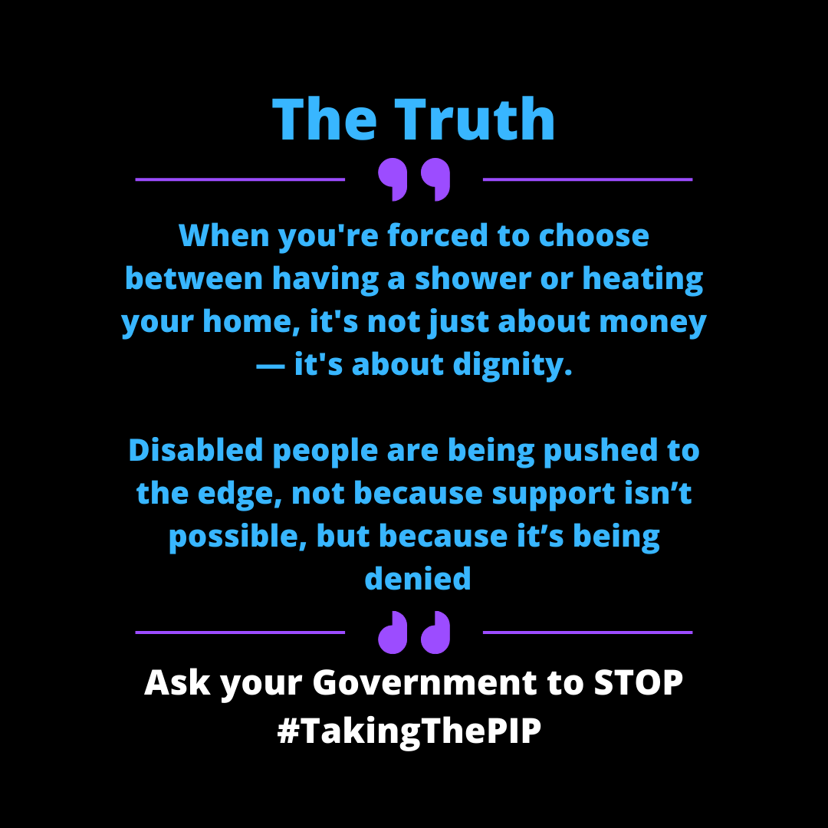

**ALT Text for: Quote 1**

A personal quote with black background with bold blue and white text saying “The Truth: When you have been forced to chose between having a shower or heating your home, it’s not just about money - it’s about dignity. Disabled people are being pushed to the edge, not because support isn’t possible, but because it’s being denied.” At the bottom, white bold text urges: "Ask your Government to STOP #TakingThePIP."

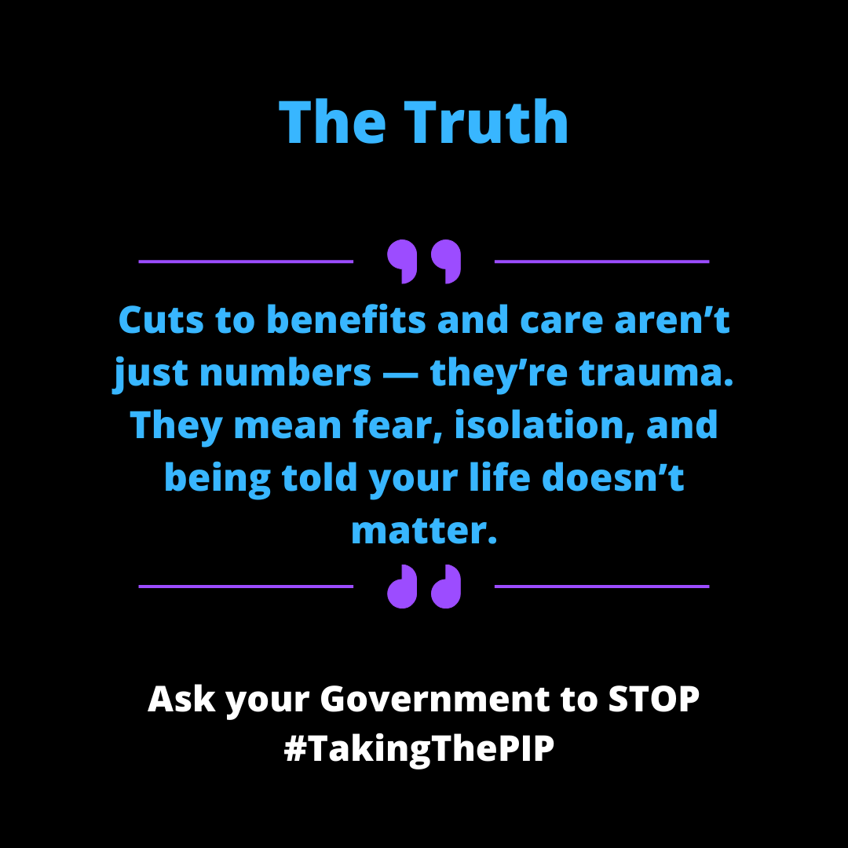

**Alt Text for: Quote 2**

A personal quote with black background with bold blue and white text saying “The Truth: Cuts to benefits and care aren’t just numbers - they’re trauma. They mean fear, isolation, and being told your life doesn’t matter.” At the bottom, white bold text urges: "Ask your Government to STOP #TakingThePIP."

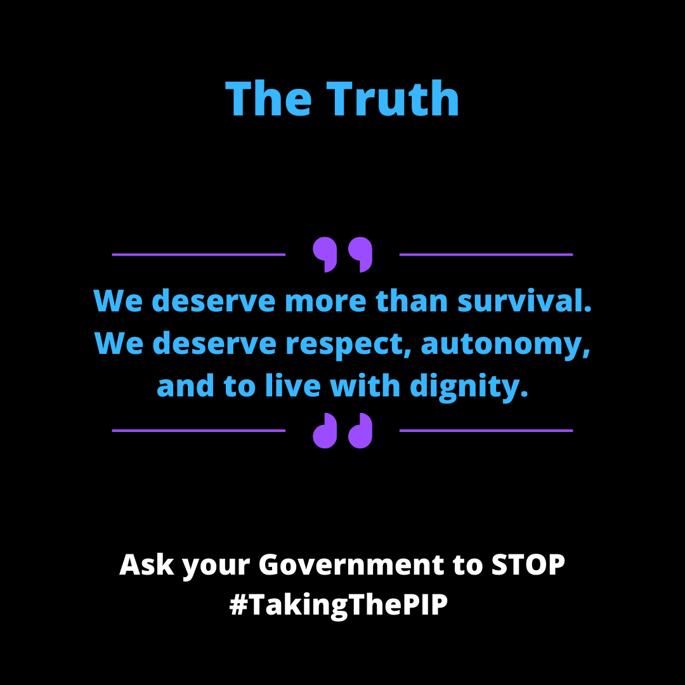

**ALT Text for: Quote 3**

A personal quote with black background with bold blue and white text saying “The Truth: We deserve more than survival. We deserve respect, autonomy, and to live with dignity.” At the bottom, white bold text urges: "Ask your Government to STOP #TakingThePIP."